**DATA BANK CASE STUDY**

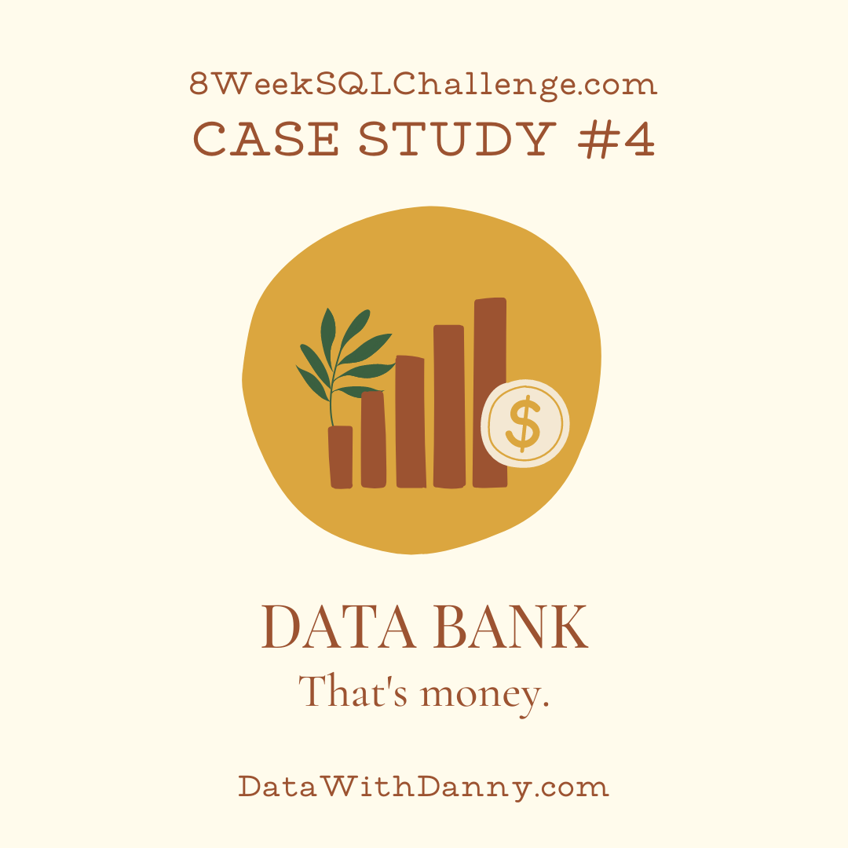

Data Bank runs just like any other digital bank - but it isn’t only for banking activities, they also have the world’s most secure distributed data storage platform!

Customers are allocated cloud data storage limits which are directly linked to how much money they have in their accounts. There are a few interesting caveats that go with this business model, and this is where the Data Bank team need your help!

The management team at Data Bank want to increase their total customer base - but also need some help tracking just how much data storage their customers will need.

This case study is all about calculating metrics, growth and helping the business analyse their data in a smart way to better forecast and plan for their future developments!

This case study contains 3 datasets

* Regions
* Customers_nodes
* Customer_transactions

1. Regions table contains the region_id and their respective region_name values

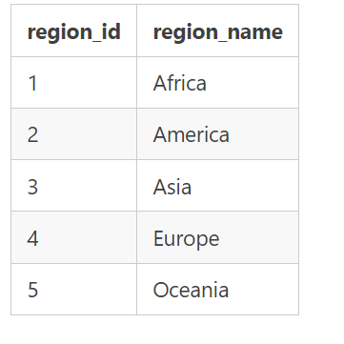

1. Customers are randomly distributed across the nodes according to their region - this also specifies exactly which node contains both their cash and data.

This random distribution changes frequently to reduce the risk of hackers getting into Data Bank’s system and stealing customer’s money and data!

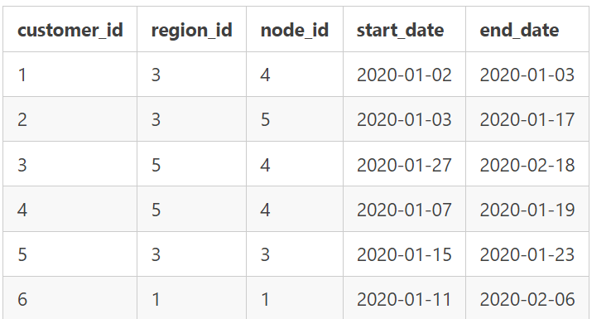

3.This table stores all customer deposits, withdrawals and purchases made using their Data Bank debit card

.